System and Software Architecture Description (SSAD)

Amer I Can Re-Up Website

Team 09

Team Members Roles

Varun Brahme Project Manager Prototyper

Priyanka Bhalerao Prototyper Operational Concept Engineer

Siddharth Sohoni Requirements Engineer Life Cycle Planner

Suparna Dawalkar Feasibility Analyst Software Architect

Anumeha Srivastava Operational Concept Engineer Requirements Engineer

Jeff Tonkovich IV&V System Engineer

12/5/2011

Version History
Date | Author | Version | Changes made | Rationale
10/07/11 | SD | 1.0 | - SSAD Draft | - Initial draft of SSAD
10/14/11 | SD | 1.1 | - Enhanced System Context Diagram  - Updated Behavior Diagram  - Added process descriptions for all capabilities | - To be consistent with the current system capabilities
10/18/11 | SD | 2.0 | - Updated process descriptions  - Edited system context diagram  - Updated Behavior Diagram | - Changes required as per TA’s suggestions
10/19/11 | SD | 3.0 | - Enhanced System Context Diagram  - Updated Behavior Diagram  - Fixed bugs | - Changes required in response to bugs identified
10/20/11 | SD | 4.0 | - Updated Artifacts and Information Diagram  - Added use cases to the behavior diagram | - Changes made as per clients and TAs suggestions
10/24/11 | SD | 5.0 | - Updated Artifacts and Information Diagram  - Edited use case diagrams | - Changes made by suggestions given in FCR ARB
11/21/11 | SD | 6.0 | - Added Section 3  - Edited System Context Diagram  - Updated Artifacts an Information Diagram | - Changes made for Draft DC Package  - Suggestions given by TA, IV&V
11/30/11 | SD | 7.0 | - Edited Section 3  - Updated Artifacts an Information Diagram | - Changes made for DC Package  - Suggestions given by TA, IV&V
12/5/11 | SD | 8.0 | - Edited Software Component Diagram | - Changes made as per suggestions given in DCR ARB

Table of Contents
System and Software Architecture Description (SSAD) i
Version History ii
Table of Contents iii
Table of Tables iv
Table of Figures vi
1. Introduction 1
1.1 Purpose of the SSAD 1
1.2 Status of the SSAD 1
2. System Analysis 3
2.1 System Analysis Overview 3
3. NDI/NCS Interoperability Analysis 18
3.1 Introduction 18
3.2 System Structure 19
3.3 Evaluation Summary 21

Table of Tables
Table 1: Actors Summary 4
Table 2: Artifacts and Information Summary 6
Table 3: Process Description 8
Table 4: Typical Course of Action 8
Table 5: Alternate Course of Action 8
Table 6: Process Description 9
Table 7: Typical Course of Action 9
Table 8: Alternate Course of Action 9
Table 9: Process Description 10
Table 10: Typical Course of Action 10
Table 11: Alternate Course of Action 10
Table 12: Process Description 10
Table 13: Typical Course of Action 11
Table 14: Alternate Course of Action 11
Table 15: Process Description 11
Table 16: Typical Course of Action 12
Table 17: Alternate Course of Action 12
Table 18: Process Description 12
Table 19: Typical Course of Action 12
Table 20: Process Description 13
Table 21: Typical Course of Action 13
Table 22: Exceptional Course of Action 13
Table 23: Process Description 14
Table 24: Typical Course of Action 14
Table 25: Process Description 14
Table 26: Typical Course of Action 14
Table 27: Process Description 15
Table 28: Typical Course of Action 15
Table 29: Process Description 15
Table 30: Typical Course of Action 16
Table 31: Exceptional Course of Action 16
Table 32: Process Description 16
Table 33: Typical Course of Action 16
Table 34: Exceptional Course of Action 17
Table 35: NDI Products Listing 18
Table 36: NDI Evaluation 21

Table of Figures
Figure 1: System Context Diagram 4
Figure 2: Artifacts and Information Diagram 5
Figure 3: Process Diagram 7
Figure 4: Hardware Component Diagram 19
Figure 5: Software Component Diagram 20
Figure 6: Deployment Diagram 21

Introduction

Purpose of the SSAD
The purpose of the System and Software Architecture Description (SSAD) is to document the architecture of the system being developed, which in this case is the Amer I Can Re-up Website. This document gives the feasible architecture of the system. It will help the developers to ensure that the system being developed is in synchronization with the decided architecture of the system. It will also be helpful to the clients and maintainers to understand the architecture of the system, once the system is delivered.

Status of the SSAD
This is version 7.0 of the SSAD. All sections of the SSAD are complete at this point of time. The document includes the System Context, the artifacts and information created by the system, the various use-case scenarios that the system will go through, its behavior and its various capabilities, along with the exceptional course of action that the system might take under certain conditions. This version also includes NDI Interoperability Analysis, the deployment diagrams, which show the physical (hardware) and logical (software) deployment of the system. The SSAD concludes with the advantages and evaluation of the NDI selected for the project implementation.

System Analysis

System Analysis Overview
The primary purpose of the Amer I Can Re-up Website is to provide the members of the website the ability to enter the tasks and long term goals that they want to accomplish and also to enter the sacrifices they are willing to make in order to accomplish their tasks and long term goals. The website and other participating members who form a given member’s ‘squad’ hold each other accountable to their submitted tasks and goals. A member can add a maximum of 25 members to his squad. The system also provides the user the functionality to upload his personal legend (a video blog) and theme song. The system will generate the statistics for each member depending on the grades assigned to him by the members in his squad. Those statistics include – will power, myG (grades), task totals and honor code. The system will also generate a report card on a quarterly basis, first quarter being January 1st to March 31st, and so on. The contents of the report card will be myG, honor code, task totals, and will power. The report cards will be stored in the database so that the user can view them whenever he wants to.

System Context
The system context diagram shows the actors outside the system that interact with the system. Our project involves actors like anonymous user, member and squad member. The member of the website will interact with the website interface and the mobile app interface [future scope].
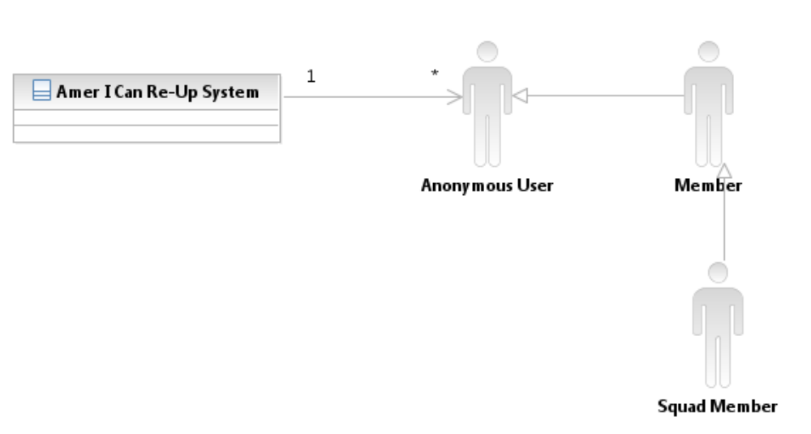
Figure 1: System Context Diagram

Table 1: Actors Summary
Actor | Description | Responsibilities
Member | A member is a user of the website. The user will have to register with the website to become a member. | Add/update status  Enter tasks in the ttBox (3<=task <=5)  Add sacrifices for each task that has been entered in the ttBox.  Upload personal legend, theme song.  View report card  Search other members; add a member to his/her squad
Squad Member | A type of member of the website who grades other members of the squad he is a part of. | A squad member along with performing all the functions that a member can perform, also grades other members in his squad.
Anonymous User | Any person who can visit the website, and watch the tutorial video and register to become a member. | An anonymous user can only watch the tutorial video and can register (sign up) to become a member of the website.

Artifacts & Information

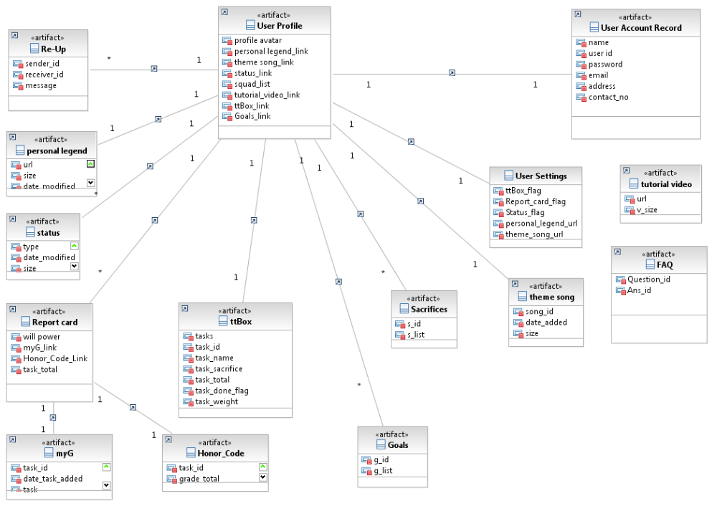

Figure 2: Artifacts and Information Diagram

Table 2: Artifacts and Information Summary
Artifact | Purpose
User profile | Contains the user’s profile page information like his personal legend video, theme song, ttBox, statistics, etc.
User account Record | Database contains information about the user’s details
ttBox | Contains all the tasks entered by the user. It is a flex component, which is plugged in to Drupal. A user can enter up to 5 tasks in the ttBox.
Sacrifices | Contains the sacrifices entered by the user; the user can enter a maximum of 5 sacrifices.
Goals | Contains the goals entered by the user; the user can enter 1 major and 3 minor goals.
FAQ | Contain a list of commonly asked questions regarding the website.
Report Card | A quarterly artifact generated by the system that contains the user’s statistics like myG, will power, honor code and task totals.
Status | It is an artifact that will be displayed on the member’s profile page, and the member can either quote it himself (free speech), or motto.
Re-Up | Contains information that a user can post in his squad like job postings, internships, etc.
Tutorial Video | Contains a video that shows first time users the purpose of the website and how to go about using the website.
Honor Code | Contains the data about the user’s grades that have been given to him by the members of his squad.
myG | Contains the grades of the member as given by the system.
Theme song | Contains a song that will be played when all the tasks in the ttBox are complete.
Personal Legend | Contains a video that the user can choose to upload, which will be available on the profile page of the member.

Behavior

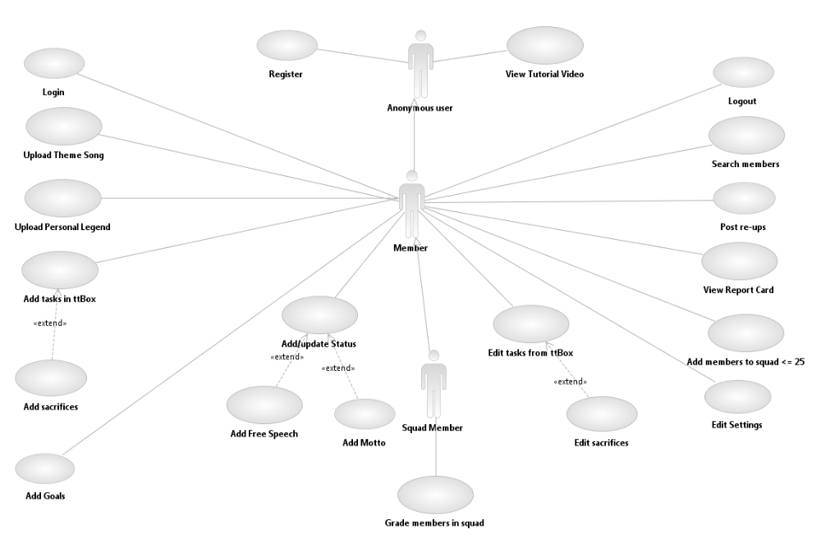

UC-1

Figure 3: Process Diagram

Login

Authenticate and redirect
Table 3: Process Description
Identifier | UC-1 : Login
Purpose | Determine if a registered user can log in successfully into the system, and is authorized to use all the functions that he/she is eligible for.
Requirements | WC_154 Details provided by the user in the new user form.
Development Risks | ---
Pre-conditions | Proper initialization of the database, servers.
Post-conditions | If the user is authenticated, he/she will be logged in and a session will be created.

Table 4: Typical Course of Action
Seq# | Actor’s Action | System’s Response
1 | User enters login name and password
2 | User clicks on Login Button | The user is authenticated by the system.
 |  | The user is taken to his/her profile page.
Table 5: Alternate Course of Action
Unsuccessful Login:

Seq# | Actor’s Action | System’s Response
1-2 | Same as Table 4: Typical Course of Action
3 |  | A window pops up stating “Invalid Username and/or password”
4 | Click on OK button | The user is redirected by the system to the main page of the website.

Register

Authenticate and redirect
Table 6: Process Description
Identifier | UC-1 : Register
Purpose | Register a new user to become a member of the website
Requirements | WC_154 Details provided by the new user in the registration form
Development Risks | ---
Pre-conditions | Proper initialization of the database, servers.
Post-conditions | If the user is registered to become a member, the user’s profile details will be stored into the database. The user will be logged in and a session will be created.

Table 7: Typical Course of Action
Seq# | Actor’s Action | System’s Response
1 | User enters data in the registration form.
2 | User clicks on ‘Sign Up’ Button | The data entered is validated by the system.
3 |  | The user’s data is successfully added to the database.
4 |  | The user is logged in, taken to his profile page, and a session is created.

Table 8: Alternate Course of Action
Seq# | Actor’s Action | System’s Response
1 | User enters some invalid data in the registration form.
2 | User clicks on ‘Sign Up’ Button | The data entered is checked by the system.
3 |  | Wrong information entered by the user is displayed in a prompt window.
4 |  | The user is taken back to the registration page to re-enter correct information.

Add tasks to the ttBox
Table 9: Process Description
Identifier | UC-1 : Add tasks to ttBox
Purpose | Enable a member of the website to add tasks that he wishes to accomplish into the ttBox.
Requirements | WC_151 Provide the user capability to add tasks to the ttBox
Development Risks | ---
Pre-conditions | Proper initialization of the database, servers.
Post-conditions | The tasks will be added to the database table – ttbox

Table 10: Typical Course of Action
Seq# | Actor’s Action | System’s Response
1 | User enters upto 5 tasks | The entered tasks will be displayed in the ttBox and the user will be prompted to enter sacrifices.
Table 11: Alternate Course of Action

Seq# | Actor’s Action | System’s Response
1 | The user may choose to edit or alter an already existing task
2 |  | Same as for typical course of action.

Upload Personal Legend

Table 12: Process Description
Identifier | UC-1 : Register
Purpose | Enables a member to upload his personal legend which is a video that the user wishes to display on his/her profile page.
Requirements | WC_152 Upload personal legend on profile page.
Development Risks | ---
Pre-conditions | Proper initialization of the database, servers.
Post-conditions | The personal legend will be stored on the cloud. The link for the video will be stored in the database. The user himself and other members will be able to view the video. Any user can view any other user’s personal legend video.

Table 13: Typical Course of Action
Seq# | Actor’s Action | System’s Response
1 | User clicks on ‘Upload Personal Legend’ | The system will ask the user to input the URL of the location of the video.
 |  | Once the URL is given, the system will check whether the syntax entered is that of an URL or not.
 |  | The system will update the path in the database.

Table 14: Alternate Course of Action
Seq# | Actor’s Action | System’s Response
1 | User clicks on ‘Upload Personal Legend’ | The system will ask the user to input the URL of the location of the video.
 |  | If not, the user will be prompted to enter a valid URL, and will be taken back to the upload personal legend tab.

Upload Status Message
Table 15: Process Description
Identifier | UC-1 : Upload Status Message
Purpose | Enable a member of the website to upload auto motto or free speech, which are types of status messages
Requirements | WC_158 Upload Status – Motto/Free Speech
Development Risks | ---
Pre-conditions | Proper initialization of the database, servers.
Post-conditions | The status message will be added to the database. The member’s status message will be visible to his squad in the news feed.

Table 16: Typical Course of Action
Seq# | Actor’s Action | System’s Response
1 | User clicks on ‘Add/edit status’ | The system will give the user an option to enter his own status message – which is of two types – motto or free speech.
 |  | The corresponding status message will be displayed on the user’s profile page, visible to his squad.
Table 17: Alternate Course of Action

Seq# | Actor’s Action | System’s Response
1 | The user may choose to remove his status message from his profile. | The system will remove the corresponding status message from the user’s profile.
 |  | The status message will no longer be displayed on the user’s wall.

Upload Theme Song
Table 18: Process Description
Identifier | UC-1 : Upload Theme Song
Purpose | Enables the user to upload a theme song that will be played when the user completes all his tasks.
Requirements | WC_471 Upload a theme song which plays when all tasks are complete.
Development Risks | ---
Pre-conditions | Proper initialization of the database, servers.
Post-conditions | The theme song will be stored on the cloud. The link to the theme song on the cloud will be stored in the database.

Table 19: Typical Course of Action
Seq# | Actor’s Action | System’s Response
1 | User clicks on ‘Upload Theme song’ | The system will prompt the user to enter the theme song.

Add up to 25 members in your squad
Table 20: Process Description
Identifier | UC-1 : Add up to 25 members in your squad
Purpose | Enables a member of the website to add up to 25 members in his/her squad.
Requirements | WC_148 Users have the capability to add a maximum of 25 members to their squad.
Development Risks | ---
Pre-conditions | Proper initialization of the database, servers.
Post-conditions | The database will be updated to reflect the additions that a member has made to his squad. The number of members and pointers to their profile will be stored in the user’s table in the database.

Table 21: Typical Course of Action
Seq# | Actor’s Action | System’s Response
1 | User adds a member to his squad | The system will check in the database whether the number of members in the squad is less than 25.
2 |  | If yes, the system will add that corresponding detail to the database.
3 |  | The system will display a message to the user stating “Member successfully added to your squad”
User tries to add 26th member to his squad:
Table 22: Exceptional Course of Action

Seq# | Actor’s Action | System’s Response
1 | User tries to add 26th member to his squad, which exceeds the maximum number 25. | The system will display a message to the user “Maximum number of members reached. Please delete some member from your squad to add a new member”

Post Re-Ups to member/s:
Table 23: Process Description
Identifier | UC-1 : Post Re-Ups
Purpose | Enables a member of the website to post re-ups to a particular member’s profile. The user can post the re-up to one or more members.
Requirements | WC_161 A user can post re-ups to a squad, or keep public.
Development Risks | ---
Pre-conditions | Proper initialization of the database, servers.
Post-conditions | The Re-Up

Table 24: Typical Course of Action
Seq# | Actor’s Action | System’s Response
1 | User will post a particular re-up to one or more members. | That re-up will appear on either the squad member’s profile or can be made public.

Set sacrifices
Table 25: Process Description
Identifier | UC-1 : Set sacrifices
Purpose | Enables a member of the website to add sacrifices for the tasks that he has entered in the ttBox.
Requirements | WC_1103 A user can add up to 5 sacrifices.
Development Risks | ---
Pre-conditions | Proper initialization of the database, servers.
Post-conditions | The database will be updated to reflect the sacrifices that the user has given.

Table 26: Typical Course of Action
Seq# | Actor’s Action | System’s Response
1 | User adds one/more sacrifices for the tasks entered in the ttBox | The system will add the sacrifices to the database for the corresponding task.
2 |  | The system will display the sacrifices for a task, when the user’s cursor hovers over the task.

Set Goals

Table 27: Process Description
Identifier | UC-1 : Set Goals
Purpose | Enables a member to set goals (1 major, 3 minor)
Requirements | WC_1102 A member can set goals.
Development Risks | ---
Pre-conditions | Proper initialization of the database, servers.
Post-conditions | The system will store the goals in the database.

Table 28: Typical Course of Action
Seq# | Actor’s Action | System’s Response
1 | User adds goals to his profile. | The system will add the goals to the database.
2 |  | The system will display the goals on the member’s profile page.

Search a member

Table 29: Process Description
Identifier | UC-1 : Search a member
Purpose | Enables a member to search other members of the website
Requirements | WC_149 Query based searching of other members of the website.
Development Risks | ---
Pre-conditions | Proper initialization of the database, servers.
Post-conditions | The system will search the database and return the corresponding results.

Table 30: Typical Course of Action
Seq# | Actor’s Action | System’s Response
1 | User types a name in the search box | The system will search for the corresponding name in the database.
2 |  | The system will return the member’s profile as a result of the query.

Table 31: Exceptional Course of Action

Seq# | Actor’s Action | System’s Response
1 | User types a name in the search box | The system will search in the database to find the corresponding member.
 |  | If such a member does not exist, the system returns “Member not found” message in result of the query.

View Report Card

Table 32: Process Description
Identifier | UC-1 : View Report Card
Purpose | Enables a member to view his quarterly report card
Requirements | WC_743 Report card - quarterly
Development Risks | ---
Pre-conditions | Proper initialization of the database, servers.
Post-conditions | The system will retrieve the corresponding user’s report from the database.

Table 33: Typical Course of Action
Seq# | Actor’s Action | System’s Response
1 | User clicks on ‘view report card’ | The system will search in the corresponding user’s record .
2 |  | The system will display the report card to the user on his profile.

Table 34: Exceptional Course of Action

Seq# | Actor’s Action | System’s Response
1 | User clicks on ‘view report’, when he has not completed even the first quarter. | The system will search in the database to find the corresponding report card.
 |  | The system will display a message to the user saying that “Report card not complete”

NDI/NCS Interoperability Analysis

Introduction
The website is going to be developed using Drupal, which is a content management system, as a framework. Drupal is an open source, easy to use framework that is especially advantageous for developing social reality/networking websites, like the Amer I Can Re-Up Website.

COTS / GOTS / ROTS / Open Source / NCS
Based on the various advantages offered by Drupal like development flexibility, ease of use, we plan to use Drupal as our NDI. It is advantageous to use Drupal for development of social networking/reality websites.
Table 35: NDI Products Listing
NDI/NCS Products | Purposes
Acquia Drupal Dev Desktop 7.4.4 | Drupal is an open source Content Management System, that will be used an infrastructure framework for the development of our website.  It is a Drupal specific xAMP stack installer, which means Apache Server, MySQL, PHP.  It consists of Acquia Drupal, Apache HTTP Server, MySQL Database Server, PHP, phpMyAdmin, Control Panel, Xmail Server.

Connectors
The system is using PHP to connect to the MySQL Database.
The PHP connectors will manage the data transfer between various modules and the MYSQL database.

Legacy System
The Amer I Can Re-Up System is a completely new concept and the clients do not have an existing system in place. So we are not using any legacy system code for development.

System Structure
The system will be deployed on a hardware server hosting Linux CentOS. The software components like PHP, MySQL and Apache Web Server will run on Drupal that will be deployed on the server.
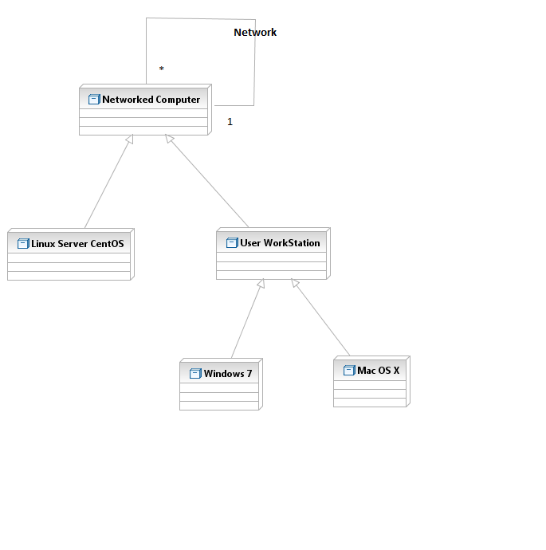
Figure 4: Hardware Component Diagram

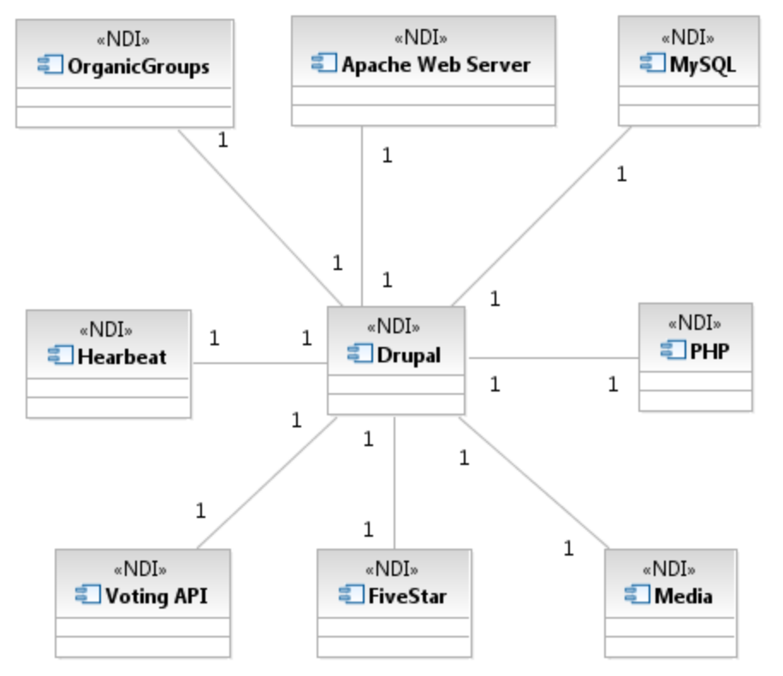
Figure 5: Software Component Diagram
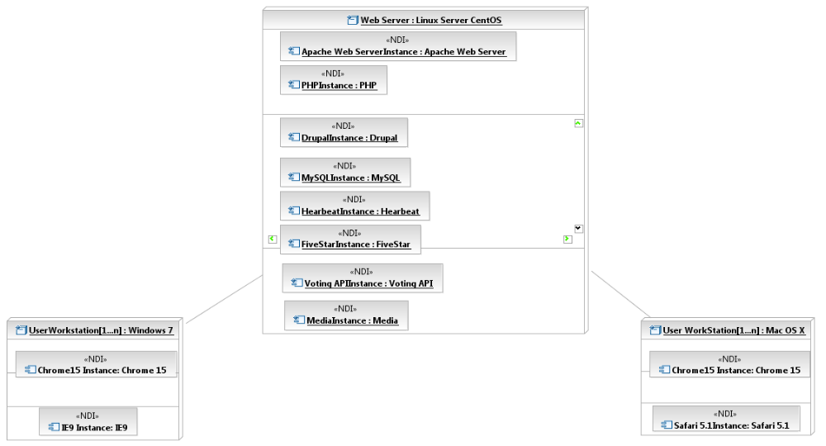
Figure 6: Deployment Diagram

Evaluation Summary

Table 36: NDI Evaluation
NDI | Usages | Comments
Acquia Drupal Dev Desktop 7.4.4 | Drupal, is a powerful content management system, that is used for developing websites:  - that generally have high traffic,  - need to be modified frequently.  Drupal provides a lot of modules that can just be plugged in to suit your application needs, and if such a module does not exist, it is easy to develop your own module. | Thus, due to the advantages offered by Drupal, we have chosen this CMS as a framework for the development of our website.  Drupal can handle increasing traffic, which is usually the case with social reality websites.  Flexibility, scalability and a fair amount of security are the factors that make Drupal a choice for our project.

